EXPERIMENT 11
Comparative Analysis of Zero-shot, One-shot and Few-shot Prompting
Name | P Nishanth
Register Number | 192472292

AIM
To compare zero-shot, one-shot, and few-shot prompting approaches using sample responses for the same topic.

PROCEDURE
- Choose a common task: explain Artificial Intelligence.
- Prepare a zero-shot prompt without examples.
- Prepare a one-shot prompt with one example.
- Prepare a few-shot prompt with multiple examples.
- Display the sample response for each prompting method.
- Compare the methods based on examples used, relevance, clarity, and consistency.

PROGRAM
print("Comparative Analysis of Prompting Techniques")

print("\nZero-shot Prompting:") print("AI enables machines to perform tasks that normally") print("require human intelligence.")

print("\nOne-shot Prompting:") print("Artificial Intelligence helps computers perform") print("intelligent tasks, similar to the given example.")

print("\nFew-shot Prompting:") print("AI allows machines to learn patterns, understand") print("information, and solve problems using data.")

print("\nComparison:")
print("Zero-shot: Uses no examples.") print("One-shot: Uses one example.") print("Few-shot: Uses multiple examples.")

OUTPUT

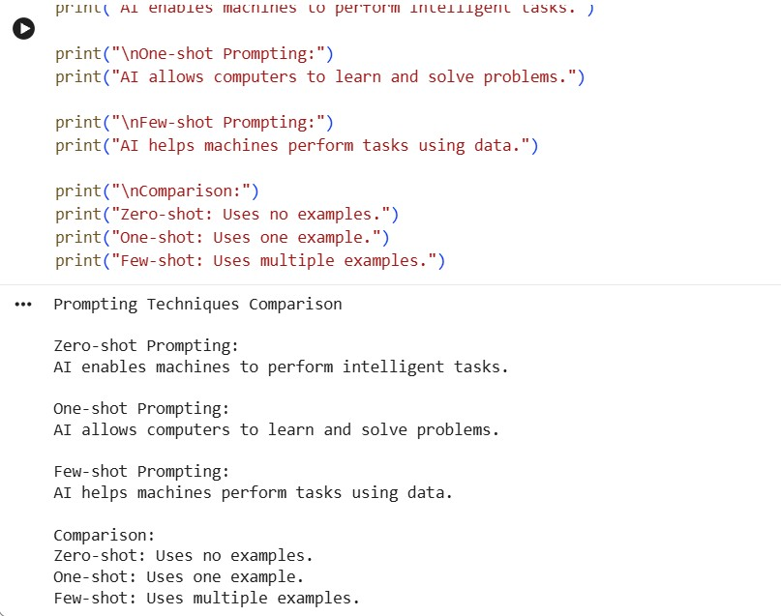

RESULT
Thus, the zero-shot, one-shot, and few-shot prompting approaches were demonstrated and compared.

